Exercises Biol-480 “Neuroscience” – Alzheimer’s disease

(10/11/2025)

General questions
- Where in the brain does Alzheimer’s disease (AD) start?
- Name 5 symptoms of Alzheimer’s disease (hint: the 5 A’s to diagnose AD).
- What are the two main features that differentiate AD from non-AD age-related dementia?
- Name 3 pathophysiological hallmarks of AD.
- What is “Braak and Braak” staging?

Case study
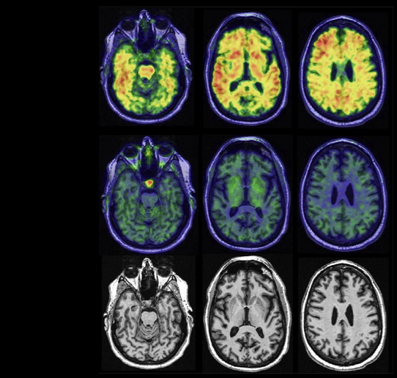
MRI
Tau PET
Amyloid PET
This figure shows PET and MRI scans of a cognitively unimpaired 67-year-old man.
- Do you observe any abnormalities in the amyloid PET images? Describe what you see and what it indicates.
- Do you observe any abnormalities in the tau PET images? What does this suggest about tau pathology at this stage?
- Do you observe any visible abnormalities on the MRI images? What does this tell you about brain atrophy?
- Based on the PET and MRI findings, can you conclude that this patient has Alzheimer’s disease? What makes diagnosis difficult at this stage?

PET imaging of Tau Deposition
You will analyze images from a study of tau accumulation in the human brain (Schöll et al., 2016, Neuron). They used AV-1451 as the tau PET agent to examine retention patterns in cognitively normal older people (OA = older adults) compared to young controls (YA = young healthy adults) and patients with Alzheimer’s disease (AD).
β-amyloid is measured using PiB PET.
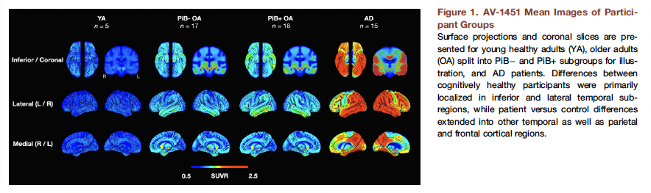
- Which brain region shows the earliest signs of tau tracer uptake in older adults compared to young adults? What do you conclude from the tau tracer uptake in this region, even in amyloid-negative older adults?
- What do you observe when comparing amyloid-negative and amyloid-positive older adults? What does this suggest about the relationship between amyloid and tau?
- What do you observe when you compare amyloid-positive older adults and AD patients? What can you conclude?
- When looking at all the images and the brain regions involved, what does tau accumulation predict here?
- What are the advantages and limitations of PET imaging compared to post-mortem histology for studying tau pathology in aging and AD?

